

HEART DISEASE DIAGNOSTIC ANALYSIS AND PREDICTION

PROJECT BY: AMANTLE MICHELLE MAKATI
DATE COMPLETED: 14 MARCH 2026

Overview of the Project
Cardiovascular diseases (CVDs) remain the leading cause of global mortality, claiming an estimated 17.9 million lives annually. Among these, heart failure represents a critical clinical milestone. It is a chronic condition where the heart's pumping capacity can no longer meet systemic demands. Rather than a standalone pathology, heart failure is the functional end-stage of various cardiovascular complications. Consequently, early identification of high-risk individuals is a vital necessity for effective clinical intervention and improved patient outcomes.

This project utilizes a clinical dataset of 918 observations to model the relationship between patient demographics and physiological health, with the primary objective of enabling the early detection of heart disease. To achieve this, the analysis was guided by three core investigative pillars: understanding the demographic drivers of illness, comparing the reliability of subjective symptoms against objective clinical tests, and evaluating the predictive power of cardiac stress markers. Following a comprehensive EDA phase to identify these risk factors, a Logistic Regression model was developed to classify patients into 'Normal' (0) or 'Heart Disease' (1) categories. The resulting framework acts as a predictive screen, allowing healthcare providers to prioritize patients and initiate preventative care protocols before the onset of heart failure.

Dataset Features
Feature | Meaning
Heart Disease | Target variable (output class [1: heart disease, 0: Normal])
age | age of the patient [years]
Sex | sex of the patient [M: Male, F: Female]
Chest Pain Type | chest pain type [TA: Typical Angina, ATA: Atypical Angina, NAP: Non-Anginal Pain, ASY: Asymptomatic]
Resting BP | resting blood pressure [mm Hg]
Cholesterol | serum cholesterol [mm/dl]
Fasting BS | fasting blood sugar [1: if FastingBS > 120 mg/dl, 0: otherwise]
Resting ECG | resting electrocardiogram results [Normal: Normal, ST: having ST-T wave abnormality (T wave inversions and/or ST elevation or depression of > 0.05 mV), LVH: showing probable or definite left ventricular hypertrophy by Estes' criteria]
Max HR | maximum heart rate achieved [Numeric value between 60 and 202]
Exercise Angina | exercise-induced angina [Y: Yes, N: No]
Oldpeak | oldpeak = ST [Numeric value measured in depression]
ST_Slope | the slope of the peak exercise ST segment [Up: upsloping, Flat: flat, Down: downsloping]

Project Workflow
To build a reliable model for predicting heart disease patients, a step by step process was followed known as a Machine Learning Pipeline. This ensured the model learned from the data correctly and could make fair predictions for new patients.
Phase 1: Data Acquisition & Initial Inspection
The foundation of the project began with gathering and understanding the raw data.
- Dataset Loading: The clinical dataset (918 observations) was imported using Python's pandas library.
- Data Auditing: Performed a high-level scan on the dataset to identify data types, missing values, and the mathematical distribution of clinical measurements.

Phase 2: Data Cleaning (The Pre-processing Stage)
Raw data often contains errors or noise that can confuse a machine learning model.

- Handling Logical Errors: "Zero" values in Cholesterol and RestingBP were identified which are medically impossible for living patients.
- Imputation Strategy: Instead of deleting these rows, Median Imputation was used. The median was chosen over the mean because it is more robust against outliers, ensuring that extreme cases did not distort the typical clinical values.

Phase 4: Data Visualization of the entire dataset

- Target Balance: A pie chart was used to verify the distribution of Heart Disease (1) vs. Normal (0) cases, ensuring the dataset was balanced for training.
- Outlier Detection: Boxplots were generated for all numerical features (Age, MaxHR, etc.) to identify extreme clinical cases and determine if they were typos or genuine medical anomalies.

Phase 5: Data Preparation & Splitting
To ensure the model's reliability, the data was prepared for the Logistic Regression algorithm.

- Train-Test Split: The data was split into a Training Set (80%) and a Testing Set (20%). This blind test ensures the model is evaluated on data it has never seen before and avoids data leakage. The shape of each of the training and test dataframes were generated to check if the expected rows were there and correlate with the percentage split of both the train and test data. The expected number of rows in the training dataframe were 734 rows and, as for the test data, the expected rows were 184 rows and .
- Feature Encoding:
- Binary Mapping: Simple categories were converted to 1s and 0s.
- One-Hot Encoding: Complex categories were expanded into multiple binary columns.
- Feature Scaling: (Came after Phase 5) Numerical values were standardized to ensure that variables with large ranges do not overpower variables with small ranges.
- A final sanity check for the training and test datasets were done and all the categorical columns were successfully encoded to numerical data and the number of columns in the training data perfectly matched with the number of columns in the test dataframe. As for the feature scaling the sanity check was done and the scaled data had means and standard deviations of zero to check if indeed they were scaled.

Phase 6: Exploratory Data Analysis and Feature Engineering
Visualized the data to uncover hidden patterns and health trends.
Heatmaps were used on the training dataframe to avoid data leakage to see which variables had the strongest correlation with heart disease

Phase 7: Model Development & Evaluation
The final stage involves training the computer to identify and predict heart disease.

- Model Selection: Logistic Regression was chosen for its effectiveness in binary classification tasks (Normal vs. Heart Disease).
- Performance Metrics: The model was evaluated using Accuracy, Precision, Recall, F1-Score.

Project Technical Stack
- Language: Python
- Environment: Google Colab
- Libraries:
- Data Manipulation: Pandas, NumPy
- Visualization: Matplotlib, Seaborn
- Machine Learning: Scikit-Learn (sklearn)

OVERVIEW EDA AND VISUALIZATION OF THE ENTIRE DATASET
DISTRIBUTION OF HEART DISEASE CASES
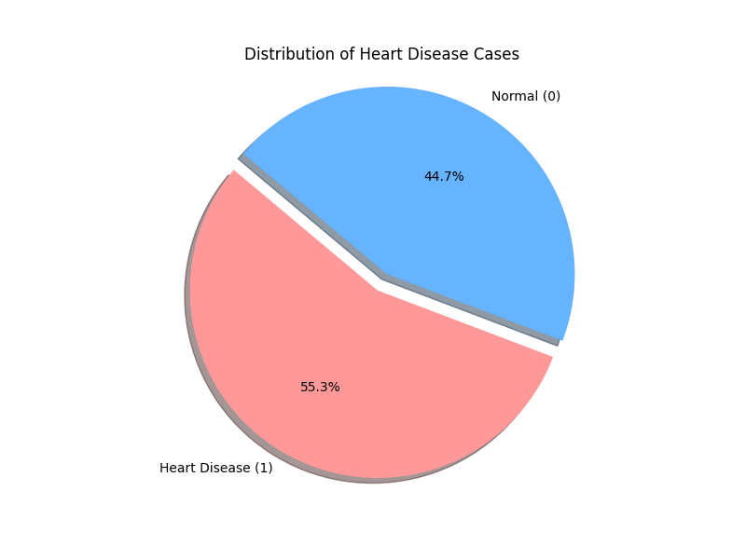

Interpretation: The above analyzed the overall balance of the dataset to ensure it provided a fair representation of both healthy and high-risk of heart disease individuals. Using a pie chart to visualize the HeartDisease target variable, 55.3% of the patients in the study were diagnosed with heart disease, while 44.7% were categorized as normal This is an ideal distribution for machine learning because the two groups are nearly equal in size, the model can learn the specific characteristics of both healthy and diseased hearts with similar accuracy. If one group were significantly smaller than the other, the model might become "biased" toward the majority, but our balanced results provide a stable foundation for a reliable predictive framework.

OUTLIERS BOX PLOT
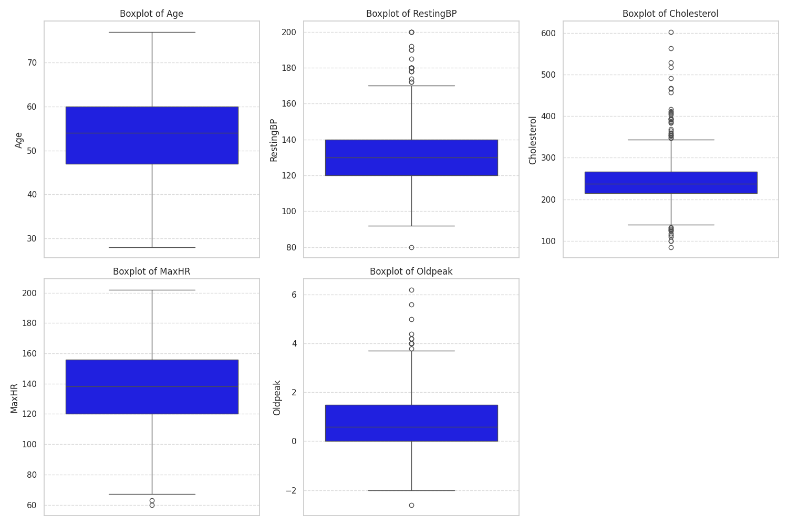

Interpretation: The analysis used boxplots to spot outliers (data points that sit far away from the typical patient that sits on the acceptable range). With Age, the data showed a smooth distribution with no outliers. Resting Blood Pressure several outliers on the high end (above the whiskers), were observed representing patients with severe high blood pressure (hypertension; some reaching 200 mmHg). One outlier on the low end was noted, indicating a patient with unusually low blood pressure. The Cholesterol column contained many high end outliers, highlighting patients with critically high cholesterol levels (some over 400 mg/dl). Conversely, a few outliers appeared at the bottom, showing patients with unusually low cholesterol. With MaxHR (Maximum Heart Rate) a few outliers sat below the whiskers, these represent patients with low exercise heart rates, which can sometimes be a sign that the heart is struggling to keep up with physical stress. Lastly Oldpeak (Heart Stress), many outliers on the high end, representing patients with significant ST depression. Since Oldpeak measures how much stress the heart is under during exercise, these outliers highlight the patients most likely to have underlying heart issues. In a medical context, these are not just errors or noise, they often represent the most high-risk cases.

RESEARCH QUESTIONS
To better understand the underlying patterns in the dataset, specific research questions were formulated to examine how each clinical feature influences the probability of heart disease. This interaction analysis was essential for revealing exactly where cardiac risks are concentrated across different demographic profiles, symptomatic patterns, and physiological markers.

- Demographic Profiles
The initial research questions that I formulated before analysis:
- Does heart failure only affect the elderly people more than young people in this dataset?
- In this dataset, which sex (male or female) has a higher frequency of heart disease?
The new added question during exploration of the dataset:
- Which age-sex segment exhibits the highest prevalence of heart disease within the study population?

- Symptomatic Patterns
The initial research questions that I formulated before analysis:
- Does having a symptom such as chest pain guarantee a person to be having a heart disease?
The new added question during exploration of the dataset:
- Which specific categories of Chest Pain Type has the highest prevalence of HeartDisease patients, making it one of the features to use to predict a patient having a heart disease?

- Physiological Markers
The initial research questions that I formulated before analysis:
- Is having diabetes (FastingBS 'Blood Sugar') a high risk indicator of having a heart disease?
- How does resting blood pressure and serum cholesterol affect the likelihood of a heart disease diagnosis?
The new added question during exploration of the dataset:
- Which specific electrocardiogram (EKG/ECG, measures the electrical activity, rate, and rhythm of the heart) ST_Slope shape (Flat, Up, or Down) acts as the strongest mathematical weighted trigger for heart failure when combined with the depth of ST depression (Oldpeak)?
- Does the presence of heart disease consistently lower the Maximum Heart Rate across all age-group dummy variables, and which specific age 'switch' (e.g., age_56-70(Senior)) shows the most dramatic drop in cardiac performance?
- Does ExerciseAngina (chest pain during a workout) act like a 'speed limiter' for the MaximumHR (maximum heart rate)? By looking at this plot, can we see a clear 'performance gap' where sick patients are forced to stop at a lower heart rate than healthy people?
- How do specific RestingECG categories, such as Left Ventricular Hypertrophy (LVH), correlate with a higher probability of heart disease, and do they serve as an early warning sign for the distress we see later in the stress test?

4.1. DATA VISUALIZATION OF THE RESEARCH QUESTIONS
Below will be the charts and graphs of each research question mentioned to get a better understanding of which features have an influence in identifying and predicting a patient to have a heart disease. Exploratory Data Analysis (EDA) and Feature engineering were implemented mostly on train dataframes and the new columns were made sure to be implemented on both the train and test dataframes as they have to mirror each other so that the model does not get confused.
- DEMOGRAPHIC PROFILE QUESTIONS:
- Does heart failure only affect the elderly people more than young people in this dataset?
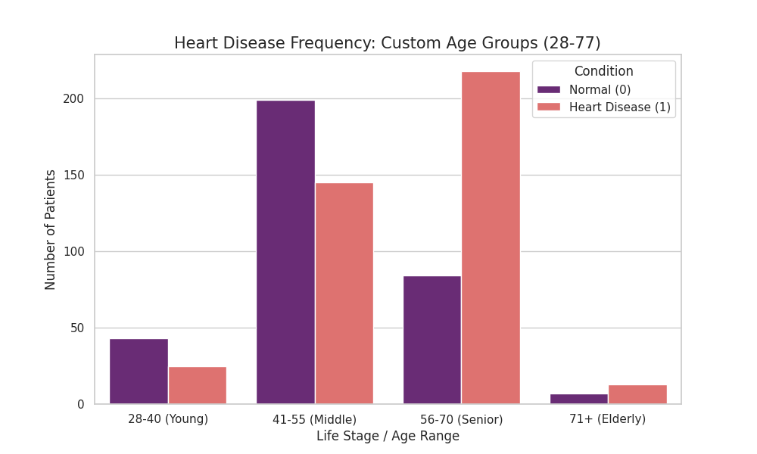

Age Group | Heart Disease Risk (%)
28-40 (Young) | 36.764706
41-55 (Middle) | 42.151163
56-70 (Senior) | 72.185430
71+ (Elderly) | 65.000000
Interpretation: The demographic analysis revealed a strong positive correlation between aging and heart disease prevalence. The risk remained relatively stable through early adulthood and middle age (ranging from 36% to 42%) before reaching a critical peak of 72% in the Senior (56-70) segment. Interestingly, the risk actually decreased slightly in the 71+ group (elderly) compared to the 56-70 group (72.19% to 65.00%).This could be due to patients who live past 70 might be healthier overall or have managed their conditions better than those who developed severe issues in their senior segment. This suggests that while heart disease can manifest as early as age 28, the clinical risk more than doubles as patients enter their late 50s, making this a high-priority window for preventative screening. This could be due to the Senior age segment being the age range where long term factors like high blood pressure or years of high cholesterol, which culminates in a clinical heart condition.

- In this dataset, which sex (male or female) has a higher frequency of heart disease?
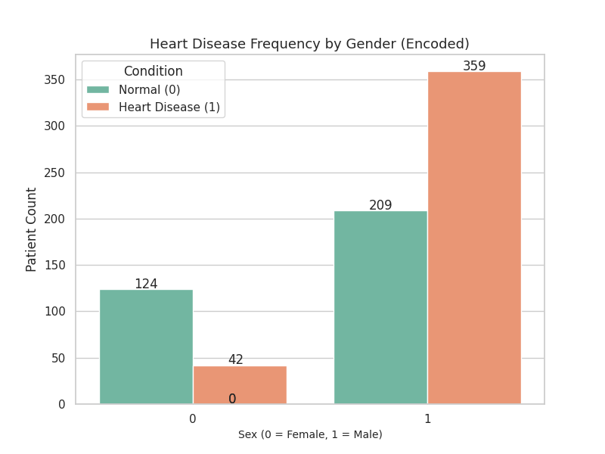
Sex/Gender | Percentage of Heart Disease by Gender (%)
0 (Female) | 25.301205
1 (Male) | 63.204225
Interpretation: Analysis of the training data revealed a significant sex-based disparity in cardiac pathology. Normalized values (percentages) rather than raw counts were used to ensure the comparison is fair, even if there were more men than women in the dataset. Patients encoded as Male (1) exhibited a heart disease prevalence of 63.2%, whereas the Female (0) cohort showed a much lower prevalence of 25.3%. This gap suggests that sex is a critical determinant of risk within this dataset. Consequently, the predictive model is expected to weigh the sex feature heavily, identifying the male demographic as a high-priority group for early diagnostic screening.
The higher prevalence of heart disease in men compared to women is driven by a combination of biological, physiological, and behavioral factors. Biologically, women benefit from higher levels of estrogen, which serves as a natural cardioprotective shield by improving cholesterol levels and maintaining vessel flexibility. Physiologically, men are more prone to storing visceral fat (a high-risk fat located around internal organs), whereas women typically store fat in less hazardous areas. These biological disadvantages in men are often compounded by lifestyle accelerants such as higher historical rates of smoking and alcohol consumption, along with a tendency to delay seeking medical attention for symptoms like chest pain due to social or work related stress.
- Which age-sex segment exhibits the highest prevalence of heart disease within the study population?
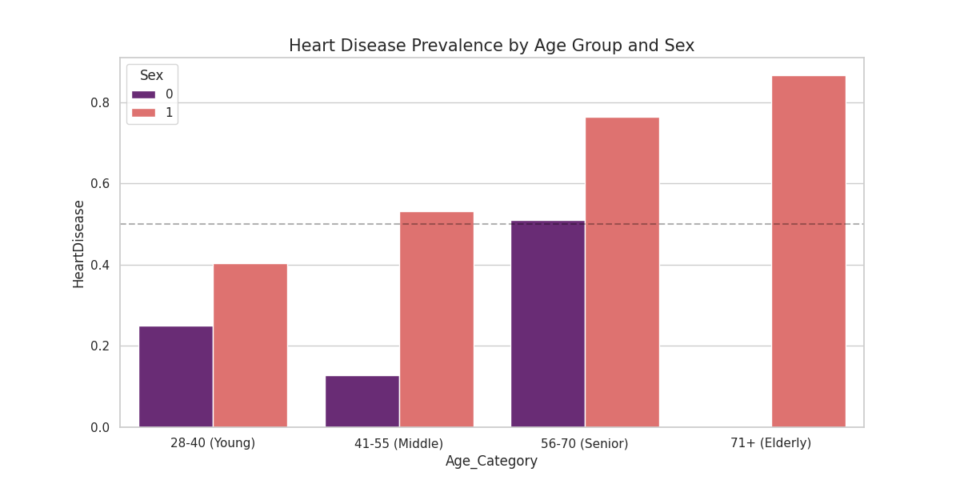
Interpretation: The analysis of heart disease prevalence across demographic segments revealed a multifaceted risk landscape where gender acts as a more consistent predictor than age alone. While advancing age was a confirmed driver of pathology (peaking in the 56–70 (Senior) cohort) the disparity between male and female risk remains the most significant finding. A striking trend is observed in the male demographic, where heart disease probability entered a critical zone (exceeding 0.5 probability) as well as the 41–55 (Middle Aged) bracket. In contrast, female risk levels remained significantly lower and did not show a similar acceleration until much later in life, specifically at the 56-70 (Senior) segment. Across every age category represented in the training set, male patients exhibited a substantially higher prevalence of heart disease. This consistent gap underscores the necessity for gender-stratified screening protocols, as traditional age based thresholds may overlook the early onset of risk in males. Notably, the 71+ (Elderly) female cohort showed zero probability of heart disease within this training partition. While this segment contained five patients, all were classified as Normal (0). This localized absence of pathology likely reflects a combination of a small sample size and healthy survivor bias, where females in this age bracket who are capable of undergoing clinical stress testing represent an exceptionally healthy subset of the population.

- Symptomatic Patterns
- Does having a symptom such as chest pain guarantee a person to be having a heart disease?
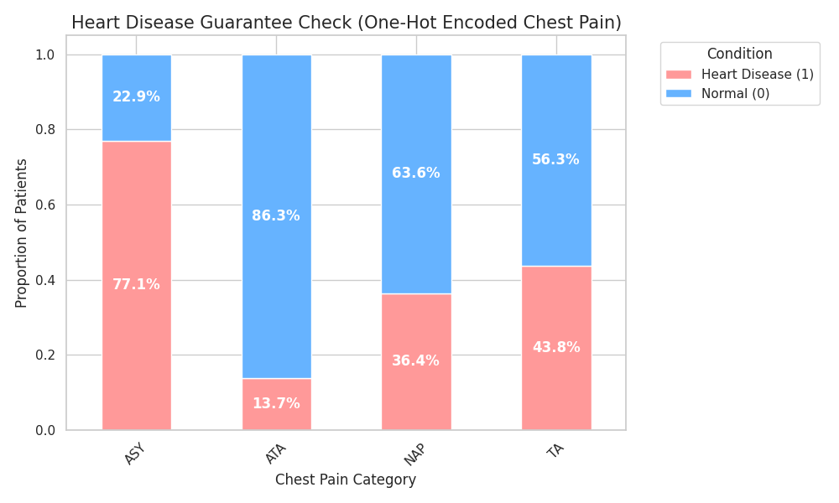
Interpretation: Due to the hypothetical question above, there was no guarantee that just having chest pain was a predictor of having a heart disease. This was seen by the bars of each chest pain type having a split between blue (Normal = 0) and red (HeartDisease = 1). There was no bar with a 100% of either definitely being normal or having a heart disease. Moreover if there was a 100% guarantee (which is likely impossible), there would have been no need for a model to help predict if a patient is prone to a heart disease.

- Which specific categories of Chest Pain Type has the highest prevalence of HeartDisease patients, making it one of the features to use to predict a patient having a heart disease?
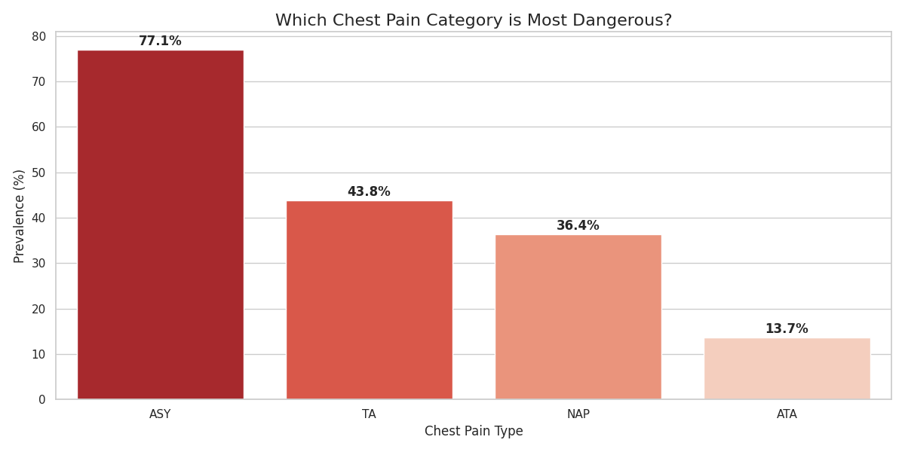
Interpretation: Analysis of the ChestPainType feature revealed a critical distinction between clinical visibility and pathological certainty. By decomposing these categories into dummy variables, the model can isolate the unique pathological weight of each symptom, allowing for a granular differentiation between high risk indicators and symptomatic noise. Contrary to intuitive expectations, Asymptomatic (ASY) cases exhibited the highest prevalence of heart disease at 77.1%. This category represents silent ischemia (a reduction in blood flow that occurs without traditional, intense chest pain). ASY cases lack a physical warning light, they often remain undetected until the pathology is advanced, resulting in a higher concentration of positive heart failure diagnoses within this cohort.
Typical Angina (TA) ranked as the second highest indicator with a 43.8% prevalence. While TA fits the classic clinical description of heart disease (pain triggered by exertion and relief by rest), it falls behind ASY in predictive certainty. This is largely due to early detection. The classic nature of the pain prompts immediate medical intervention, often before the condition reaches a critical stage.
Lastly, categories such as Atypical Angina (ATA) and Non-Anginal Pain (NAP) showed significantly lower prevalence (36.4% and 13.7%, respectively). These frequently represent false alarms in a cardiac context, where the reported discomfort is likely attributed to gastrointestinal issues or musculoskeletal strain rather than cardiovascular distress.

- Physiological Markers
- Is having diabetes (FastingBS 'Blood Sugar') a high risk indicator of having a heart disease?
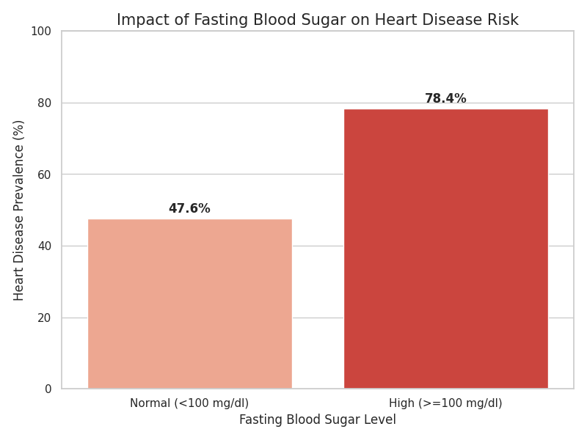
Interpretation: Typically normal fasting blood sugar is below 100mg/dl and a high fasting blood sugar is 100mg/dl and above. The patients with high fasting blood sugar (>= 100mg/dl) had a high heart disease prevalence of 78.4%, while the patients with normal fasting blood sugar (< 100mg/dl) had a heart disease prevalence of 46.6%. FastingBS of >= 100mg/dl (high fasting blood sugar) highlights its role as an indicator of heart disease. This is largely because it damages our blood vessels and nerves and can increase the risk of heart attacks or heart diseases.

- How does resting blood pressure and serum cholesterol affect the likelihood of a heart disease diagnosis?
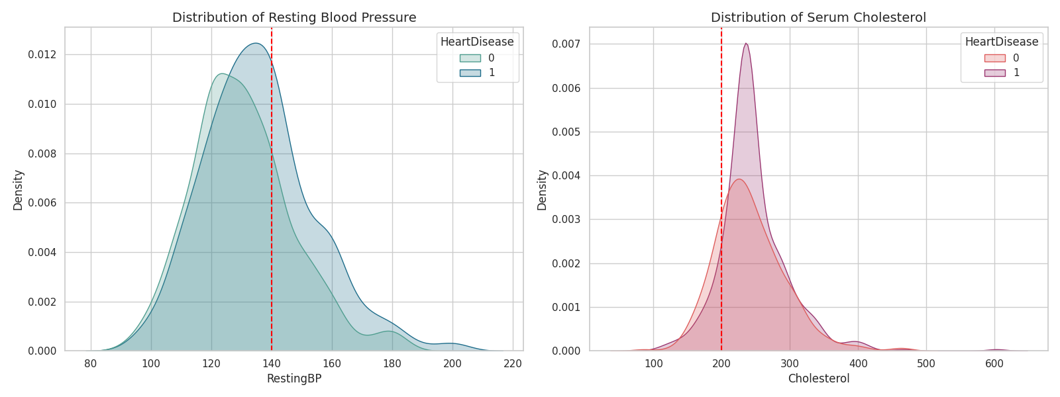
Interpretation:The distributional analysis for the RestingBP (blood pressure) revealed that both healthy (Health Disease = 0) and diseased (Health Disease = 1) cohorts primarily resided to the left of the 140 mmHg (Hypertension) threshold. This suggested that extreme high blood pressure was not the dominant driver of heart disease within this specific population. However, a subtle but critical distinction was found in the probability density. The heart disease curve exhibited a higher concentration within the pre-hypertension range (120–130 mmHg). This indicated that while heart disease patients in this dataset may not be hypertensive, they were more consistently clustered at the higher end of the normal spectrum than their healthy counterparts. Both cohorts showed significant overlap, with peaks extending beyond the 200 mg/dl clinical threshold. This indicated that elevated cholesterol was prevalent across the entire study population. While the heart disease cohort showed a notably higher density in the high cholesterol region confirming it as a consistent marker for heart failure. The substantial overlap with the normal cohort suggested that high cholesterol is a necessary but not sufficient condition. Essentially, while most sick patients had high cholesterol, many healthy patients do as well, reducing its strength as a standalone diagnostic indicator.
The significant overlap observed in both features can be attributed to two primary factors. One being the medication effect. High risk heart disease patients are often prescribed statins (for cholesterol) or beta-blockers (for BP). These interventions lower clinical numbers, shifting the diseased cohort's data points into normal ranges despite the presence of underlying heart disease. The second being that RestingBP and Cholesterol are chronic indicators representing long term cardiovascular wear and tear. They describe the patient's environment over years rather than the heart's functional state in the moment.
- Which specific electrocardiogram (EKG/ECG, measures the electrical activity, rate, and rhythm of the heart) ST_Slope shape (Flat, Up, or Down) acts as the strongest mathematical weighted trigger for heart failure when combined with the depth of ST depression (Oldpeak)?
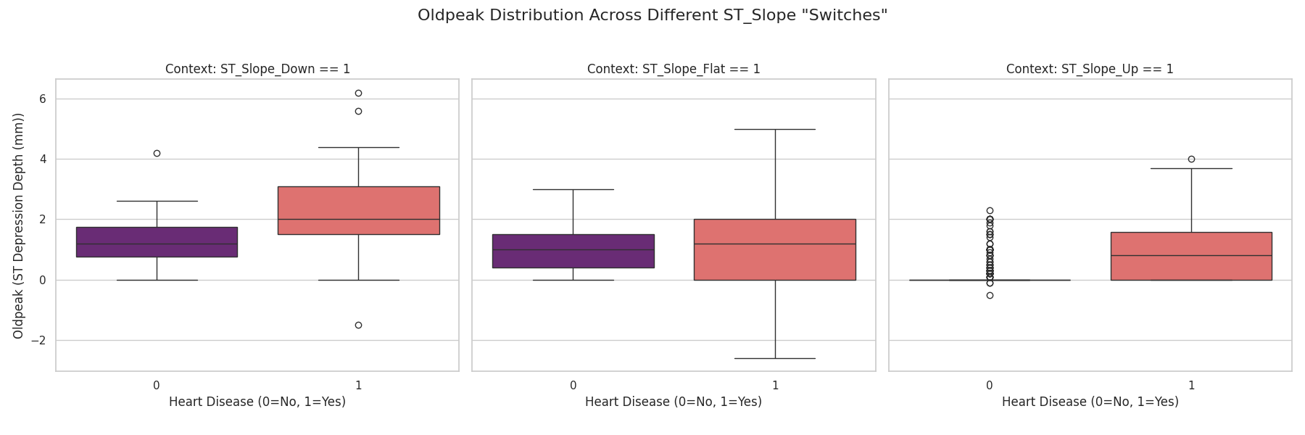
Interpretation: By visualizing the distribution of Oldpeak (ST depression; a medical measurement used during a heart stress testhow the heart handles physical activity compared to when you are rested) across the one-hot encoded ST_Slope categories (the shape of how the heart recovers), there was observation of how the intensity of electrical distress varies according to the heart's recovery pattern. When the ST_Slope_Down dummy was active, a clear divergence emerged, healthy patients consistently maintained a low Oldpeak (below 2.0 mm), while those with heart disease shifted significantly higher, typically clustering between 1.0 and 3.0 mm. This confirmed that a downward slope combined with high ST depression is a strong indicator of cardiovascular distress. In contrast, the ST_Slope_Flat category presented a unique analytical challenge. Both healthy and diseased cohorts were concentrated below the 2.0 mm mark, creating a high overlap zone where Oldpeak alone cannot reliably distinguish between the two groups. This suggested that a flat slope indicated cardiac vulnerability even at low distress levels, requiring tie-breaker features, such as age or chest pain type, to refine the diagnosis. Conversely, the ST_Slope_Up category served as the model’s negative control, representing the ideal physiological state where most healthy patients exhibit an Oldpeak of exactly 0mm. Interestingly, even in this healthy slope category, there were patients with heart disease. However, their Oldpeak was consistently below 2.0mm. This showed that for some people, heart disease was so subtle that it did not break the Upward recovery pattern of the EKG.
The individual dots observed beyond the boxplot whiskers represent clinically extreme outliers rather than data errors. High value outliers in the heart disease cohort (Oldpeak of 3.0 mm and above) signified individuals with severe arterial blockages who were struggling significantly more than the average patient. Meanwhile, outliers among healthy patients represented false positives caused by non-specific ST changes or unusual heart rhythms that mimic disease on paper. Conversely, heart disease patients with an Oldpeak of 0mm represented cases where the EKG failed to capture the underlying distress. Ultimately, these outliers and overlapping zones underscore the necessity of a multi-feature approach, as no single EKG measurement is sufficient to catch every instance of heart disease.
- Does the presence of heart disease consistently lower the Maximum Heart Rate across all age-group dummy variables, and which specific age 'switch' (e.g., age_56-70(Senior)) shows the most dramatic drop in cardiac performance?
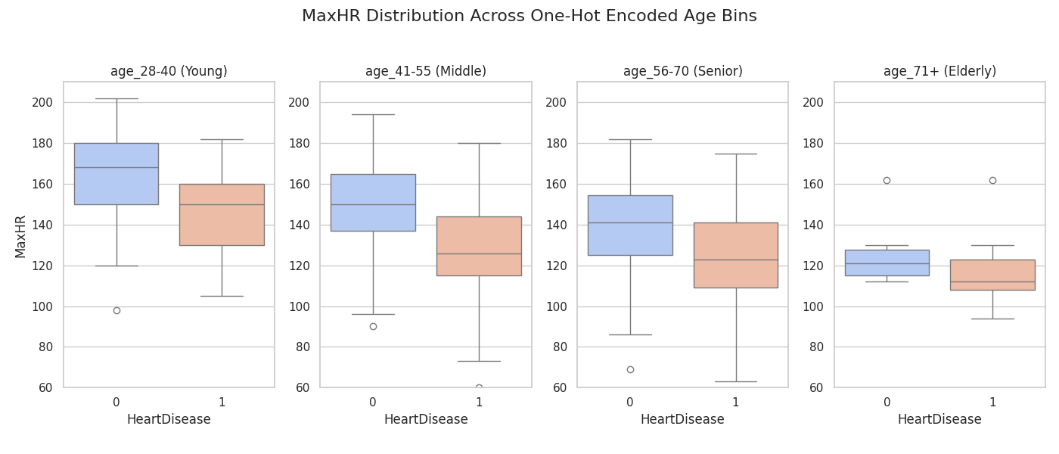
Interpretation: The observed decline in MaxHR across all age bins was consistent with the standard physiological aging process, characterized by the natural pacemaker (SA node) losing some of its sensitivity, decreased beta-adrenergic responsiveness (low adrenaline response), and the natural stiffening of the heart muscle over time makes it physically harder for the heart to beat at very high speeds. However, the critical distinction in this dataset was the relative deficit. While healthy (Health Disease = 0) patients followed the expected age-predicted decline, heart disease (Health Disease = 1) patients exhibited a significantly lower baseline in every bin. This indicated that heart disease imposes a functional tax on top of natural aging, further limiting the heart's ability to reach its peak capacity during physical exertion. Moreover, analysis revealed that the diagnostic sensitivity of MaxHR was highest in the Young (28–40) cohort, where the gap between healthy and diseased cardiac performance was most dramatic. In younger patients, heart disease causes a massive deviation from the high physiological baseline because it is easy to spot a disease against a high performance baseline. As age increases, this heart rate gap progressively narrows as disease starts to overlap with natural aging signals. By the Elderly (71+) stage, natural aging and pathological decline converge, making MaxHR a less distinct marker.
- Does ExerciseAngina (chest pain during a workout) act like a 'speed limiter' for the MaximumHR (maximum heart rate)? By looking at this plot, can we see a clear 'performance gap' where sick patients are forced to stop at a lower heart rate than healthy people?
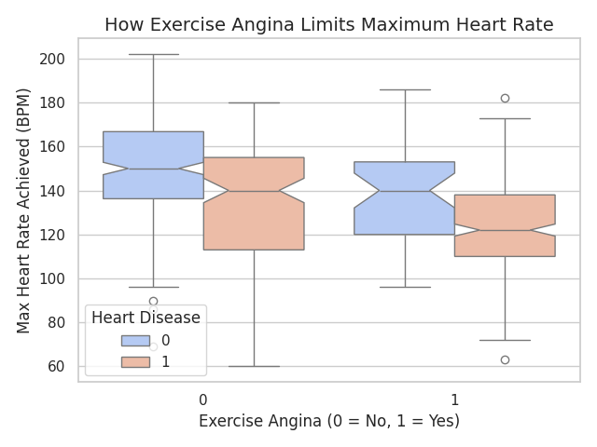
Interpretation: This visualization confirmed a powerful interaction between a patient's symptoms and their physical performance. There was a clear downward shift in MaxHR for patients who experience Exercise Angina (the “1” category). This proves that chest pain acts as a physical speed limiter, forcing patients to stop exertion before their heart can reach its full potential. Even within the same category of those without pain, patients with Heart Disease (red boxes) consistently showed a lower MaxHR than healthy patients (blue boxes). This suggests that heart disease reduces efficiency even when symptoms are not immediately present. The lowest heart rates in the entire study were found in the group that had both heart disease and exercise-induced pain. These two features are some of the most reliable predictors for a positive diagnosis.
- How do specific RestingECG categories, such as Left Ventricular Hypertrophy (LVH), correlate with a higher probability of heart disease, and do they serve as an early warning sign for the distress we see later in the stress test?
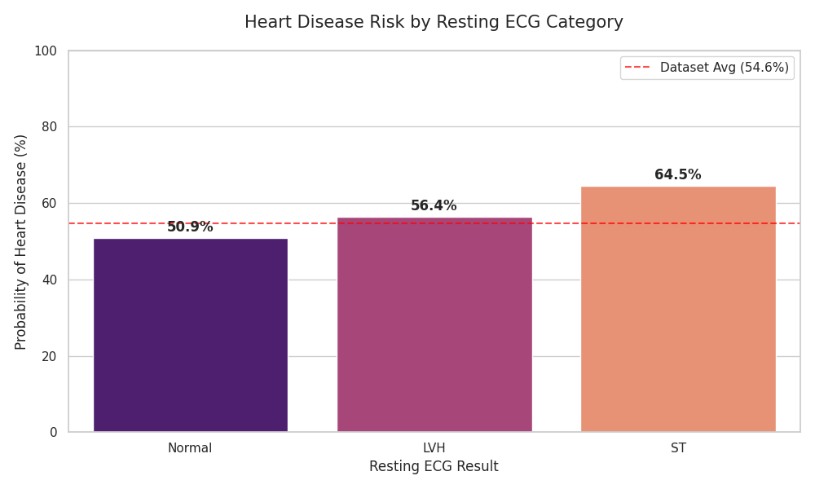
Interpretation: The analysis showed a clear "risk ladder" in which a Normal ECG (50.9% Heart Disease risk) was not necessarily a clean bill of health, but rather a neutral starting point that requires more testing to prove safety. Left ventricular hypertrophy (LVH) with a 56.4% Heart Disease prevalence acted as a structural warning, showing the heart muscle had thickened from working too hard for too long. The most serious red flag was ST-T wave abnormality that had a prevalence of 64.5% for Heart Disease, which indicated that the heart was already struggling with electrical issues or poor blood flow even before exercise began. By identifying these resting patterns, the model gained a head start, allowing it to better predict which patients will likely experience chest pain or heart rate drops during the actual stress test.

HEATMAP FOR FEATURES WITH CORRELATION TO HEART DISEASE
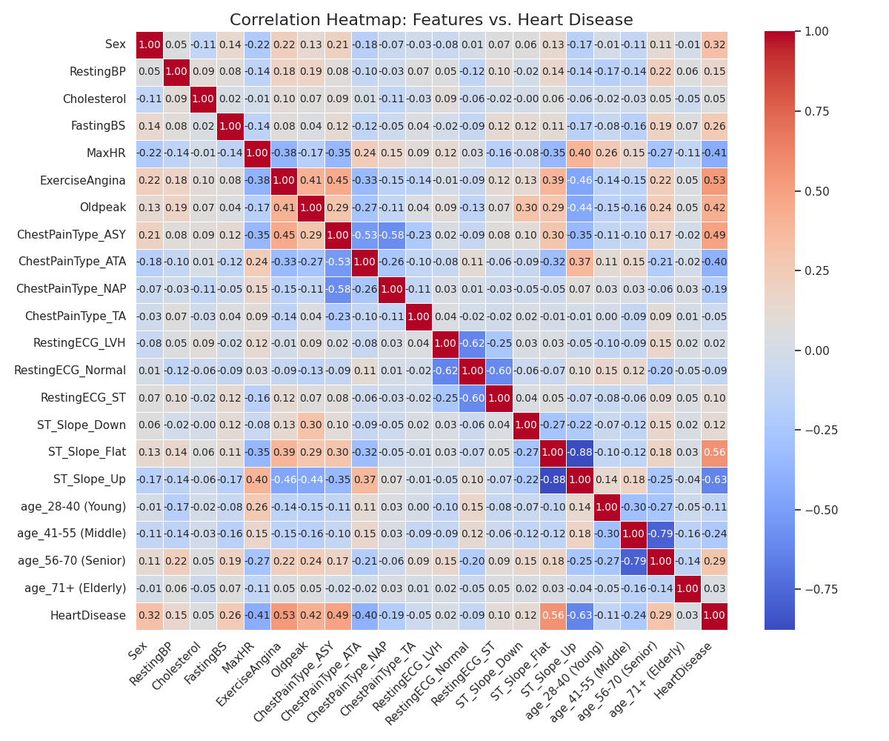
Interpretation: A correlation heatmap was generated to identify the primary drivers of heart disease within the dataset. The map revealed that Age, Sex, FastingBS, ExerciseAngina, Oldpeak, ChestPainType_ASY and ST_Slope_Flat had the strongest positive correlation that ranged from 0.26 to 0.56 with the target variable (Heart Disease), while MaxHR, ChestainType_ATA, ChestainType_NAP and ST_Slope_Up showed a significant negative correlation. This showed that physical performance and electrical stability were the most influential factors in predicting cardiovascular risk. Furthermore, the lack of extreme correlation between independent variables ensures that our model was not suffering from redundancy, allowing each feature to provide unique value.
SUMMARY: The overall analysis revealed that heart disease is a multidimensional condition characterized by a functional tax on the heart’s performance, electrical stability, and metabolic health. While MaxHR naturally declined with age, heart disease created a significant performance gap most visible in younger patients, often signaled by Exercise Angina (chest pain during exertion) which acted as a definitive physical red flag. This is further categorized by Chest Pain Type, where Typical Angina served as a classic warning, while Asymptomatic cases represented a dangerous silent risk. This functional failure was underpinned by the patient's internal environment, where high RestingBP indicated chronic arterial strain, and abnormal Cholesterol levels point to the plaque buildup that causes these blockages.
Electrically, the ST_Slope and Oldpeak measurements tracked the heart’s immediate distress during stress, while structural issues like the Left Ventricular Hypertrophy (LVH) in the RestingECG show long term foundation damage. Together, these features allowed the model to distinguish between natural aging and true cardiovascular failure by connecting a patient's symptoms and metabolic risks with their physical performance. By utilizing binned age dummies and one-hot encoded categories, our model will successfully capture these non-linear relationships, allowing for a more nuanced and accurate diagnosis than traditional linear methods.

5. MODEL DEVELOPMENT AND EVALUATION
The dataset was well balanced so the standard Logistic Regression model was used for evaluation.

 | Evaluation Metrics
 | Accuracy | Precision | Recall | F1_Score | Macro Average | Weighted Average
Class | Results (%)
Normal (0) | 86 | 81 | 87 | 84 | 86 | 86
Heart Disease (1) |  | 90 | 85 | 88

Interpretation: An accuracy of 86% means that for every 100 patients the model sees, it correctly classifies 86 of them. In the context of heart failure, this is a solid "baseline" that suggests the model has a firm grasp on the dataset's features.

Heart Disease Analysis
- Precision (90%): This was the strongest metric, which means there are a few false positives. It predicts that a patient has heart disease 90% of the time correctly.
- Recall(85%): This is the sensitivity. The model successfully identified 85% of all actual heart disease cases.
- F1-Score(88%): This is higher than the Normal groups's F1-Score, it showed that the model was actually better at identifying heart disease than it was at identifying healthy patients.

Normal Analysis

- Precision(81%): This was lower than the disease group, which meant that whe the model predicted someone to be normal it was wrong about 19% of the time (they actually had heart disease).
- Recall(87%): The model was very good at clearing healthy or normal people, correctly identifying 87% of the healthy population.
- F1-Score (84%): A solid score but slightly lower than the heart disease group due to the lower precision.

The Macro Average(86%), showed that the Heart Disease and Normal were equally important.Weighted Average (86%), accounts for the number of samples in each class. This tells us that the dataset was well balanced because the percentages for both matches the accuracy (86%)for the Logistic Regression model.
Confusion Matrix
It shows exactly where the Logistic Regression model succeeded and where it got confused.
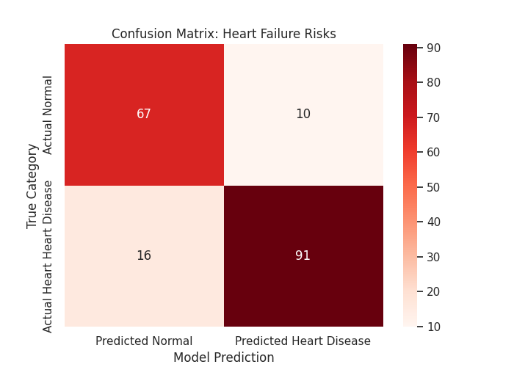

 | Predicted Normal (0) | Predicted Heart Disease (1)
Actual Normal (0) | 67 (True Negatives) | 10 (False Positives)
Actual Heart Disease (1) | 16 (False Negatives) | 91 (True Positives)
- True Positives (91): 91 heart disease patients were correctly identified as heart disease patients.
- True Negatives (67): 67 normal patients were correctly classified as normal patients.
- False Positives (10): 10 normal patients were incorrectly classified as heart disease patients.
- False Negatives (16): 16 heart disease patients were incorrectly classified as normal patients.
SUMMARY: A remarkably stable model for heart failure prediction was achieved, with a performance gap of just 1.19%. This low delta proves that our model was not just memorizing the training data but it was actually learning the real-world indicators of heart disease. The choice of Logistic Regression proved to be the ideal sweet spot for our dataset size, providing both high accuracy and reliable generalization to new patient data.

CONCLUSION
In conclusion, the Logistic Regression model for heart disease classification offered significant advancements in both patient care and healthcare system efficiency. This will enable earlier and more accurate detection of cardiovascular conditions. This model will improve patient outcomes through timely intervention and personalized treatment strategies. It will also support continuous monitoring and encourage proactive health management, reducing complications and enhancing quality of life. For healthcare providers, the Logistic Regression model will enhance clinical decision making, optimize resource allocation, and lower operational costs by minimizing unnecessary interventions and improving workflow efficiency. Overall, the integration of the Logistic Regression model into cardiovascular care represents a powerful step toward more precise, proactive, and accessible healthcare.

RECOMMENDATIONS
I suggest comparing logistic regression with more complex models such as decision trees, random forests, or gradient boosting. While logistic regression was interpretable and efficient, other models may capture non-linear relationships and potentially improve performance.

